ช่วงความเชื่อมั่นบูตสแทร็ปสำหรับค่าเฉลี่ยของการแจกแจงปัวซง-อิชิตาตัดค่าศูนย์:
กรณีศึกษาจำนวนเหตุการณ์ความไม่สงบในจังหวัดชายแดนใต้ของไทย
Bootstrap Confidence Intervals for the Mean of Zero-truncated Poisson-Ishita Distribution: A Case Study of the Number of Unrest Events
in the Southern Border Area of Thailand
วราฤทธิ์ พานิชกิจโกศลกุล¹
E-mail: wararit@mathstat.sci.tu.ac.th
บทคัดย่อ
ในหลายสถานการณ์เกี่ยวข้องกับข้อมูลจำนวนนับตัดค่าศูนย์ และการแจกแจงปัวซง-อิชิตาตัดค่าศูนย์ ซึ่งถูกนำไปใช้ในกำหนดตัวแบบ อย่างไรก็ตาม ช่วงความเชื่อมั่นบูตสแทร็ปสำหรับค่าเฉลี่ยของการแจกแจงปัวซง-อิชิตาตัดค่าศูนย์ยังไม่ได้มีการนำเสนอ การศึกษานี้จึงได้นำเสนอช่วงความเชื่อมั่นแบบเปอร์เซ็นต์ไทล์บูตสแทร็ป ช่วงความเชื่อมั่นแบบบูตสแทร็ปอย่างง่าย และช่วงความเชื่อมั่นแบบบูตสแทร็ปที่ปรับค่าเอนเอียง และเปรียบเทียบโดยพิจารณาค่าความน่าจะเป็นคุ้มรวมและความกว้างเฉลี่ยของช่วงความเชื่อมั่นด้วยวิธีการจำลองแบบมอนติคาร์โล ผลการวิจัยแสดงให้เห็นว่า ช่วงความเชื่อมั่นทุกวิธียังให้ค่าความน่าจะเป็นคุ้มรวมไม่เข้าใกล้ระดับนัยสำคัญที่กำหนด เมื่อตัวอย่างมีขนาดเล็กในทุกๆ สถานการณ์ ยิ่งไปกว่านั้นเมื่อตัวอย่างมีขนาดใหญ่มากพอ ช่วงความเชื่อมั่นทุกวิธีจะผลการจำลองไม่แตกต่างกันมากนัก ในภาพรวมพบว่าช่วงความเชื่อมั่นบูตสแทร็ปที่ปรับค่าเอนเอียงมีประสิทธิภาพมากกว่าช่วงความเชื่อมั่นวิธีอื่นๆ ถึงแม้ว่าตัวอย่างจะมีขนาดเล็กก็ตาม นอกจากนี้ ช่วงความเชื่อมั่นบูตสแทร็ปแต่ละวิธีได้นำมาประยุกต์ใช้กับจำนวนเหตุการณ์ความไม่สงบในจังหวัดชายแดนใต้ของไทยโดยให้ผลลัพธ์สอดคล้องกับผลการจำลอง

คำสำคัญ: การประมาณค่าแบบช่วง การแจกแจงปัวซง-อิชิตา ค่าเฉลี่ย วิธีบูตสแทร็ป

Abstract
Many situations involve count data containing non-zero values and the zero-truncated Poisson-Ishita distribution can be used to model such data. However, confidence interval estimation for the mean has not yet been examined. In this study, the percentile, simple, and biased-corrected and accelerated bootstrap confidence intervals were examined in terms of coverage probability and average length via Monte Carlo simulation. The results indicate that attaining the nominal confidence level using the bootstrap confidence intervals was not possible for small sample sizes regardless of the other setting. Moreover, when a sample size was large, the performances of the bootstrap confidence intervals were not substantially different. Overall, the biased-corrected and accelerated bootstrap confidence interval outperformed the others, even for small sample sizes. Lastly, the bootstrap confidence intervals were used to estimate the population mean for the zero-truncated Poisson-Ishita distribution via the number of unrest events in the southern border area of Thailand, the results of which match those from the simulation study.

Keywords: Interval estimation, Poisson-Ishita distribution, mean, bootstrap method

¹ อาจารย์ประจำสาขาวิชาคณิตศาสตร์และสถิติ คณะวิทยาศาสตร์และเทคโนโลยี มหาวิทยาลัยธรรมศาสตร์

Introduction
The Poisson distribution is a discrete probability distribution that measures the probability of a given number of events happening in specific regions of time or space (Kissell and Poserina, 2017; Andrew and Michael, 2022). Data such as the number of orders a firm will receive tomorrow, the number of calls the firm receives next week for help concerning an “easy-to-assemble” toy, the number of defects in a finished product, the number of customers arriving at a checkout counter in a supermarket from 3 to 6 p.m., etc., (Siegel, 2016) follow a Poisson distribution.
The probability mass function (p.m.f.) of a Poisson distribution is defined as
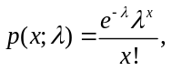 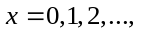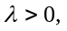 (1)
where is a constant approximately equal to 2.71828 and is the parameter of the Poisson distribution. This probability model is can be used to analyze data containing zeros and positive values that have low occurrence probabilities within a predefined time or area range (Sangnawakij, 2021). However, probability models can become truncated when a range of possible values for the variables is either disregarded or impossible to observe. Indeed, zero truncation is often enforced when one wants to analyze count data without zeros. David and Johnson (1952) developed the zero-truncated Poisson (ZTP) distribution, which has been applied to datasets of the length of stay in hospitals, the number of published journal articles in various disciplines, the number of children ever born to a sample of mothers over 40 years old, and the number of passengers in cars (Hussain, 2020). The zero-truncated distribution’s p.m.f. can be derived as

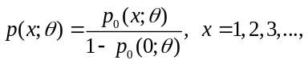 (2)
where 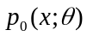 is the p.m.f. of the un-truncated distribution. Shukla and Shanker (2019) defined the p.m.f. of the Poisson-Ishita (PI) distribution as
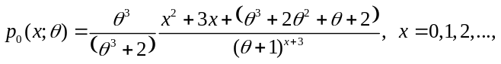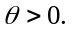 (3)
The mathematical and statistical properties of the PI distribution for modeling biological science data were established by Shukla and Shanker (2019). The PI distribution arises from the Poisson distribution when parameter follows the Ishita distribution proposed by Shanker and Shukla (2017) with probability density function (p.d.f.)
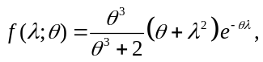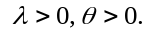 (4)
Shanker and Shukla (2017) showed that the p.d.f. in (4) is a better model than the exponential, Lindley (Lindley, 1958) and Akash (Shanker, 2015) distributions for modeling lifetime data. Many distributions have been introduced as an alternative to the zero-truncated Poisson distribution for handling over-dispersion in data, such as the zero-truncated Poisson-Lindley (ZTPL) (Ghitany et al., 2008), zero-truncated Poisson-Sujatha (ZTPS) (Shanker and Fesshaye, 2015) and zero-truncated Poisson-Akash (ZTPA) (Shanker, 2017b) distributions.
Recently, Shukla et al. (2020) proposed the zero-truncated Poisson-Ishita (ZTPI) distribution and its applications. The moment, coefficient of variation, skewness, kurtosis and the index of dispersion of ZTPI distribution had been proposed. The method of moments and the maximum likelihood method have also been derived for estimating its parameter. Furthermore, when the ZTPI distribution was applied to two real data, it was more suitable than ZTP, ZTPL, ZTPS and ZTPA distributions.
To the best of our knowledge, no research has been conducted on estimating the bootstrap confidence intervals for the mean of the ZTPI distribution. Bootstrap confidence intervals provide a way of quantifying the uncertainties in statistical inference based on a sample of data. The concept is to run a simulation study based on the actual data for estimating the likely extent of sampling error (Wood, 2004). Therefore, the objective of the current study is to assess the efficiencies of three bootstrap confidence intervals for the population mean of ZTPI distribution, namely, the percentile bootstrap (PB), the simple bootstrap (SB), and the bias-corrected and accelerated (BCa) bootstrap methods. Because a theoretical comparison is not possible, we conduct a simulation study to compare their performances and used the results to determine the best-performing bootstrap confidence interval based on the coverage probability and the average length.

Theoretical Background
Compounding of probability distributions is a sound and innovative technique to obtain new probability distributions to fit data sets not adequately fit by common parametric distributions. Shukla and Shanker (2019) proposed a new compounding distribution by compounding Poisson distribution with Ishita distribution, as there is a need to find more flexible model for analyzing statistical data. The p.m.f. of the Poisson-Ishita distribution is given by in (3).

Let be a random variable which follow ZTPI distribution with parameter 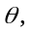 it is denoted as X~ZTPI(). Using Equations (2) and (3), the p.m.f. of ZTPI distribution can be obtained as

The plots of ZTPI distribution with some specified parameter values shown in Figure 1.
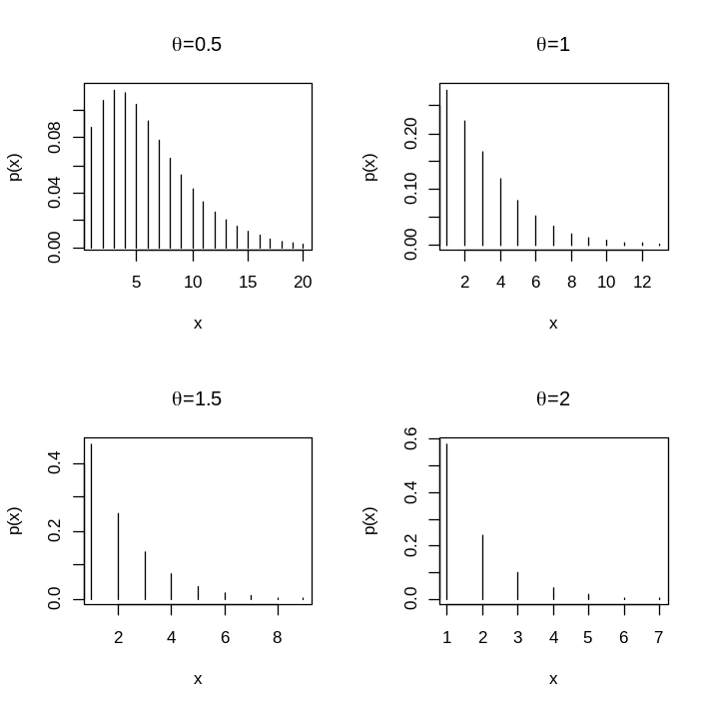
Figure 1. The plots of the mass function of the ZTPI distribution with =0.5, 1, 1.5 and 2

The expected value and variance of are as follows:

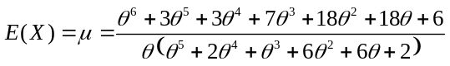 (5)

and

The point estimator of is obtained by maximizing the log-likelihood function 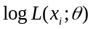 or the logarithm of joint p.m.f. of 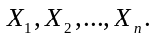 Therefore, the maximum likelihood (ML)
estimator for of the ZTPI distribution is derived by the following processes:

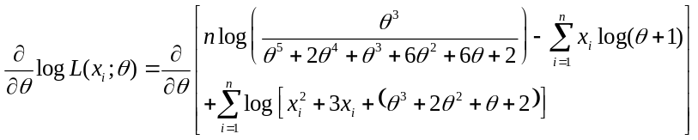

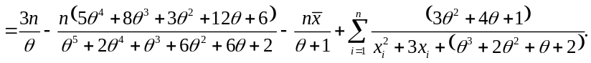

Solving the equation 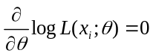 for 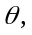 we have the non-linear equation

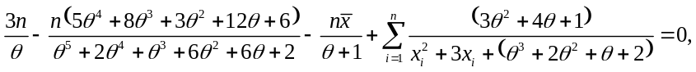

where 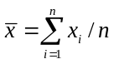 denotes the sample mean. Since the ML estimator for does not provide the closed-form solution, the non-linear equation can be solved by the numerical iteration methods such as Newton-Raphson method, bisection method and Ragula-Falsi method. In this paper, we use maxLik package (Henningsen and Toomet, 2011) with Newton-Raphson method for ML estimation in the statistical software R.
The point estimator of the population mean 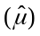 can be estimated by replacing the parameter with the ML estimator for shown in Equation (5). Therefore, the point estimator of the population mean is given by
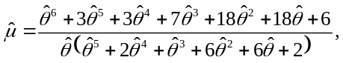
where is the ML estimator for It is obvious that the point estimator of the population mean is different from the parameter estimator 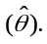

Bootstrap Confidence Interval Methods

In this study, we focus on the three bootstrap confidence interval methods that are most popular in practice: percentile bootstrap, simple bootstrap, and bias-corrected and accelerated bootstrap confidence intervals.

1. Percentile bootstrap (PB) method
The percentile bootstrap confidence interval is the interval between the 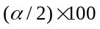 and 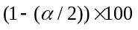 percentiles of the distribution of estimates obtained from resampling or the distribution of 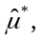 where represents a parameter of interest and is the level of significance (e.g., = 0.05 for 95% confidence intervals) (Efron, 1982). A percentile bootstrap confidence interval for can be obtained as follows:
1) random bootstrap samples are generated,
2) a parameter estimate 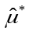 is calculated from each bootstrap sample,
3) all bootstrap parameter estimates are ordered from the lowest to highest, and
4) the 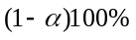 percentile bootstrap confidence interval is constructed as follows:
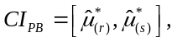 (6)
where 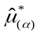 denotes the 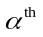percentile of the distribution of and 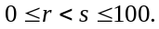 For example, a 95% percentile bootstrap confidence interval with 1000 bootstrap samples is the interval between the 2.5 percentile value and the 97.5 percentile value of the 1000 bootstrap parameter estimates.

2. Simple bootstrap (SB) method
The simple bootstrap method is sometimes called the basic bootstrap method and is a method as easy to apply as the percentile bootstrap method. Suppose that the quantity of interest is and that the estimator
of is 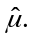 The simple bootstrap method assumes that the distributions of 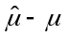 and 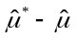 are approximately the same (Meeker et al. 2017). The simple bootstrap confidence interval for is
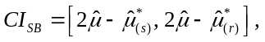 (7)
where the quantiles 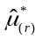 and 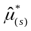 are the same percentile of empirical distribution of bootstrap estimates  used in (6) for the percentile bootstrap method.

3. Bias-corrected and accelerated (BCa) bootstrap method
To overcome the over coverage issues in percentile bootstrap confidence intervals (Efron and Tibshirani, 1993), the BCa bootstrap method corrects for both bias and skewness of the bootstrap parameter estimates by incorporating a bias-correction factor and an acceleration factor (Efron, 1987; Efron and Tibshirani, 1993). The bias-correction factor is estimated as the proportion of the bootstrap estimates less than the original parameter estimate 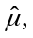
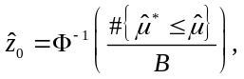
where 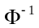 is the inverse function of a standard normal cumulative distribution function (e.g., 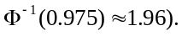 The acceleration factor is estimated through jackknife resampling (i.e., “leave one out” resampling), which involves generating replicates of the original sample, where is the number of observations in the sample. The first jackknife replicate is obtained by leaving out the first case 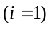 of the original sample, the second by leaving out the second case 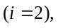 and so on, until samples of size 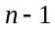 are obtained. For each of the jackknife resamples, 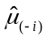 is obtained. The average of these estimates is
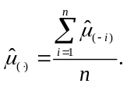
Then, the acceleration factor is calculated as follow,
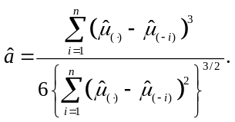
With the values of and 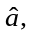 the values 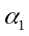 and 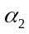 are calculated,
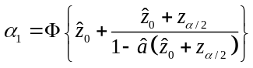 and 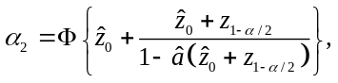
where 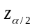 is the quantile of the standard normal distribution (e.g. 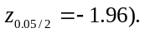 Then, the BCa bootstrap confidence interval for is as follows
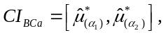 (8)
where denotes the percentile of the distribution of 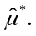

Simulation Study
In this study, the bootstrap confidence intervals for the mean of a ZTPI distribution are determined. Because a theoretical comparison is not possible, a Monte Carlo simulation study was designed using R version 4.2.2 statistical software (Ihaka and Gentleman, 1996) and conducted to compare the performances of three bootstrap confidence intervals for the mean in a ZTPI distribution. The study was designed to cover cases with different sample sizes, as = 10, 25, 50, 75 and 100, reflecting small to large samples. To observe the effect of
small and large variances, the true parameter 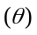 was given by 0.25, 0.5, 0.75, 1 and 2, and the population means are 12.0523, 6.0968, 4.1094, 3.1111 and 1.7182, respectively. It shows that the mean and variance of random variables will decrease as the value of increases. = 1000 bootstrap samples of size were generated from the original sample and each simulation was repeated 5000 times. Without loss of generality, the confidence level 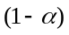 was set at 0.95. The performances of the bootstrap confidence intervals were compared in terms of their coverage probabilities and average lengths. The one with a coverage probability greater than or close to the nominal confidence level means that it contains the true value and can be used to precisely estimate the confidence interval for the mean.

Table 1. Coverage probability and average length of the 95% bootstrap confidence intervals for in the ZTPI distribution
 |  |  | Coverage probability |  |  | Average length
 |  |  | PB | SB | BCa | PB | SB | BCa
10 | 2 | 1.7182 | 0.8596 | 0.8124 | 0.9354 | 1.2000 | 1.2003 | 1.3755
 | 1 | 3.1111 | 0.8946 | 0.8666 | 0.9096 | 2.5049 | 2.5059 | 2.6504
 | 0.75 | 4.1094 | 0.8860 | 0.8706 | 0.8910 | 3.2019 | 3.1999 | 3.3505
 | 0.5 | 6.0968 | 0.8814 | 0.8652 | 0.8878 | 4.5973 | 4.5999 | 4.8053
 | 0.25 | 12.0523 | 0.8838 | 0.8740 | 0.8872 | 8.5869 | 8.5910 | 8.9717
25 | 2 | 1.7182 | 0.9134 | 0.8948 | 0.9378 | 0.8239 | 0.8239 | 0.8773
 | 1 | 3.1111 | 0.9220 | 0.9056 | 0.9306 | 1.6627 | 1.6635 | 1.7086
 | 0.75 | 4.1094 | 0.9276 | 0.9174 | 0.9294 | 2.1769 | 2.1772 | 2.2318
 | 0.5 | 6.0968 | 0.9244 | 0.9170 | 0.9272 | 3.1100 | 3.1124 | 3.1889
 | 0.25 | 12.0523 | 0.9212 | 0.9152 | 0.9268 | 5.7835 | 5.7859 | 5.9211
50 | 2 | 1.7182 | 0.9310 | 0.9204 | 0.9400 | 0.5950 | 0.5946 | 0.6146
 | 1 | 3.1111 | 0.9432 | 0.9352 | 0.9420 | 1.2053 | 1.2057 | 1.2248
 | 0.75 | 4.1094 | 0.9402 | 0.9362 | 0.9400 | 1.5667 | 1.5678 | 1.5877
 | 0.5 | 6.0968 | 0.9430 | 0.9370 | 0.9424 | 2.2455 | 2.2473 | 2.2779
 | 0.25 | 12.0523 | 0.9356 | 0.9334 | 0.9358 | 4.1784 | 4.1760 | 4.2344
75 | 2 | 1.7182 | 0.9334 | 0.9222 | 0.9426 | 0.4883 | 0.4887 | 0.5002
 | 1 | 3.1111 | 0.9416 | 0.9364 | 0.9408 | 0.9908 | 0.9903 | 1.0022
 | 0.75 | 4.1094 | 0.9436 | 0.9390 | 0.9434 | 1.2886 | 1.2887 | 1.3004
 | 0.5 | 6.0968 | 0.9404 | 0.9380 | 0.9418 | 1.8493 | 1.8475 | 1.8651
 | 0.25 | 12.0523 | 0.9466 | 0.9422 | 0.9474 | 3.4443 | 3.4450 | 3.4761
100 | 2 | 1.7182 | 0.9396 | 0.9286 | 0.9454 | 0.4237 | 0.4237 | 0.4311
 | 1 | 3.1111 | 0.9436 | 0.9398 | 0.9444 | 0.8605 | 0.8602 | 0.8672
 | 0.75 | 4.1094 | 0.9416 | 0.9358 | 0.9444 | 1.1208 | 1.1205 | 1.1286
 | 0.5 | 6.0968 | 0.9466 | 0.9456 | 0.9462 | 1.6084 | 1.6074 | 1.6187
 | 0.25 | 12.0523 | 0.9416 | 0.9420 | 0.9382 | 2.9885 | 2.9857 | 3.0071

The results of the study are reported in Table 1 and Figures 2-3. For = 10, the coverage probabilities of the three confidence intervals tended to be less than 0.90, except in a few cases where the values of are less or equal to 3.1111 for BCa bootstrap method. The nominal confidence level of SB method is difficult to reach in circumstances where 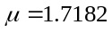 and 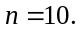 Generally, as sample size increases, the coverage probability tends to increase and approach 0.95. The average length also obviously increases when the value of increases; this is because of the relationship between the variance and value. Unsurprisingly, as sample size increases, the average length falls. It can be as small as approximately 0.8239 when is at 1.7182 and the sample size is 25; the largest average length, 5.9211, occurs when 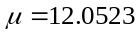 and 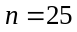 in the case of BCa method. Furthermore, the average lengths of PB method are similar to those of SB method in all situations.
The performances of the three confidence intervals differed when the variance of the distribution was small (i.e.,  for 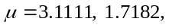 respectively) and was small (i.e., ); the BCa bootstrap method outperform the PB and SB methods in terms of coverage probability. For a small sample size, a larger variance (i.e., 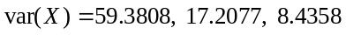 for 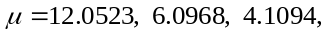 respectively) provided similar performances from all three confidence intervals.
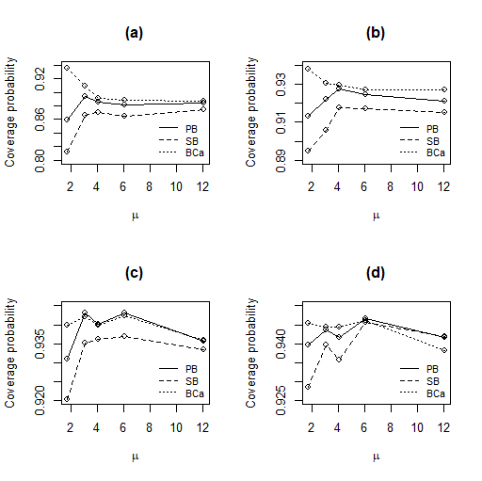
Figure 2. Coverage probability of the 95% bootstrap confidence intervals for in the ZTPI distribution when (a) 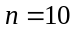 (b) (c) 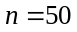 (d) 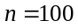

Numerical Example
We used a real-world example to demonstrate the applicabikity of the bootstrap confidence intervals for the mean of the ZTPI distribution established in the preceding section. The number of unrest events occurring in the southern border area of Thailand from July 2020 to October 2022 collected by the Southern Border Area News Summarizes (SBAN Summarizes) (http://summarise.wbns.oas.psu.ac.th) was used for this example (the total sample size is 28). The number of unrest events per month during this time period in the five southern provinces of Pattani, Yala, Narathiwat, Songkhla, and Satun is reported in Table 2 and Figure 4. For the goodness-of-fit test (Turhan, 2020) in Table 2, it is obvious from the chi-square statistic and p-value that the ZTPI distribution gives much closer than the ZTPL and ZTPS distributions. Therefore, a ZTPI distribution with =0.4532 is suitable for this dataset. The point estimator of the population mean is 6.7100. Table 3 and Figure 5 reported the 95% bootstrap confidence intervals for the mean of the ZTPI distribution. The estimated parameter is between 0.25 and 0.5. The results correspond with the simulation results for because the average lengths of the PB and SB methods were shorter than those of the BCa bootstrap method. According to the simulation results, the coverage probability should be 0.92.
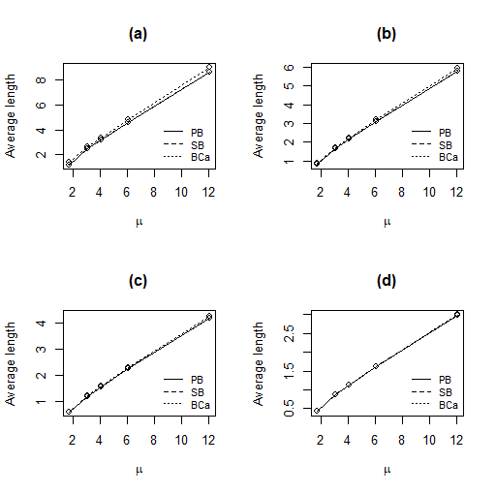
Figure 3. Average length of the 95% bootstrap confidence intervals for in the ZTPI distribution when (a) (b) (c) (d)

Table 2. The number of unrest events and expected frequency in the southern border area of Thailand
Number of unrest events | Observed frequency | Expected frequency
Number of unrest events | Observed frequency | ZTPL | ZTPS | ZTPI
1 | 3 | 3.0731 | 2.3069 | 2.0016
2 | 1 | 3.1064 | 2.7231 | 2.5728
3 | 3 | 2.9694 | 2.8944 | 2.8708
4 | 2 | 2.7370 | 2.8675 | 2.9250
5 | 4 | 2.4591 | 2.7018 | 2.7995
6 | 3 | 2.1678 | 2.4518 | 2.5601
7 | 4 | 1.8832 | 2.1611 | 2.2616
≥ 8 | 8 | 9.6040 | 9.8934 | 10.0086
ML Estimator |  | 0.2900 | 0.4252 | 0.4532
Chi-square statistic |  | 5.5611 | 4.2384 | 4.0875
d.f. |  | 6 | 6 | 6
p-value |  | 0.4741 | 0.6444 | 0.6648

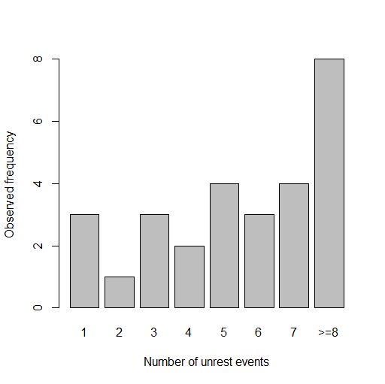
Figure 4. The number of unrest events in the southern border area of Thailand

Table 3. The 95% bootstrap confidence intervals and corresponding widths using all intervals for the mean in the unrest events example
Methods | Confidence intervals | Widths
PB | (5.1867, 8.2769) | 3.0908
SB | (5.1456, 8.1951) | 3.0495
BCa | (5.1896, 8.4390) | 3.2494

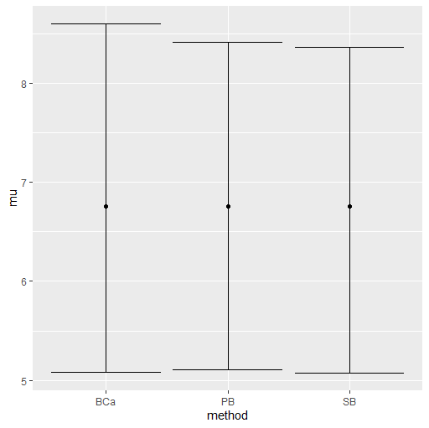
Figure 5. The 95% bootstrap confidence intervals for the mean in the unrest events example

Conclusions
The bootstrap confidence intervals of the mean of the zero-truncated Poisson-Ishita distribution are investigated in this study. At 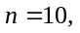 all coverage probabilities are substantially lower than 0.90. A sample size of 25 is still insufficient to achieve the nominal confidence level for all 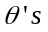 and bootstrap confidence intervals. When the sample size is large enough, i.e., greater than or equal to 50, the coverage probabilities from three bootstrap methods, as well as the average length, are not markedly different. According to our findings, the BCa bootstrap method performs best even with small sample sizes as long as the variance of the ZTPI distribution is not too large.

Acknowledgements
The author would like to thank the reviewers for the valuable comments and suggestions to improve this paper.

References
Andrew, F. S., & Michael, R. W. (2022). Practical business statistics. Academic Press.
Beran, R. (1987). Prepivoting to reduce level error of confidence sets. Biometrika. 74(3), 457–468.
David, F. N., & Johnson, N. L. (1952). The truncated Poisson. Biometrics. 8(4), 275–285.
Donna, L. M., Wilson, W. J., & Freund, R. J. (2022). Statistical methods. Academic Press.
Efron, B. (1982). The Jackknife, the bootstrap, and other resampling plans, in CBMS-NSF Regional Conference Series in Applied Mathematics, Monograph 38 (Philadelphia, PA: SIAM).
Efron, B. (1987). Better bootstrap confidence intervals. Journal of the American Statistical Association. 82(397), 171–185.

Efron, B., & Tibshirani, R. J. (1993). An Introduction to the bootstrap. Chapman and Hall.
Finney, D. J., & Varley, G. C. (1955). An example of the truncated Poisson distribution. Biometrics. 11(3), 387–394.
Garman, P. (1923). The European red mites in Connecticut apple orchards. Connecticut Agricultural Experiment Station Bulletin. 252, 103–125.
Ghitany, M. E., Al-Mutairi, D. K., & Nadarajah, S. (2008). Zero-truncated Poisson-Lindley distribution and its application. Mathematics and Computers in Simulation. 79(3), 279–287.
Henningsen, A., & Toomet, O. (2011). maxLik: A package for maximum likelihood estimation in R. Computational Statistics. 26(3), 443–458.
Hussain, T. (2020). A zero truncated discrete distribution: Theory and applications to count data. Pakistan Journal of Statistics and Operation Research. 16(1), 167–190.
Ihaka, R., & Gentleman, R. (1996). R: A language for data analysis and graphics. Journal of Computational and Graphical Statistics. 5(3), 299–314.

Kissell, R., & Poserina, J. Optimal sports math, statistics, and fantasy. Academic Press.
Letson, D., & McCullough, B. D. (1998). Better confidence intervals: The double bootstrap with no pivot. American Journal of Agricultural Economics. 80(3), 552–559.
Lindley, D. V. (1958). Fiducial distributions and Bayes’ theorem. Journal of the Royal Statistical Society: Series B. 20(1), 102–107.
McCullough, B. D., & Vinod, H. D. (1998). Implementing the double bootstrap. Computational Economics. 12(1), 79–95.
Meeker, W. Q., Hahn, G. J., & Escobar, L. A. (2017). Statistical intervals: A guide for practitioners and researchers. John Wiley and Sons.
Sangnawakij, P. (2021). Confidence interval for the parameter of the zero-truncated Poisson distribution. The Journal of Applied Science. 20(2), 13–22.
Shanker, R. (2015). Akash distribution and its applications. International Journal of Statistics and Probability. 4(3), 65–75.
Shanker, R. (2017a). The discrete Poisson-Akash distribution. International Journal of Statistics and Probability. 6(1), 1–10.
Shanker, R. (2017b). Zero-truncated Poisson-Akash distribution and its applications. American Journal of Mathematics and Statistics. 7(6), 227–236.
Shanker, R., & Fesshaye, H. (2015). Zero-truncated Poisson-Sujatha distribution with applications. Journal of Ethiopian Statistical Association. 24, 55–63.
Shanker, R., & Shukla, K. K. (2017). Ishita distribution and its application to model lifetime data. Biometrics and Biostatistics International Journal. 5(2), 1–9.
Shukla, K. K., & Shanker, R. (2019). A discrete Poisson-Ishita distribution and its applications. International Journal of Economics and Statistics. 20(2), 109–122.
Shukla, K. K., & Shanker, R., & Tiwari, M. K. Zero-truncated Poisson-Ishita distribution and its application. Journal of Scientific Research. 64(2), 287–294.

Siegel, A. F. (2016). Practical business statistics. Academic Press.
Simonoff, J. S. (2003). Analyzing categorical data. Springer.
Turhan, N. S. (2020). Karl Pearson’s chi-square tests. Educational Research Review. 15(9), 575–580.
Wood, M. (2004). Statistical inference using bootstrap confidence intervals. Significance. 1(4), 180–182.

